

Alaska Fisheries Science Center
Sablefish Longline Survey Database
and Web Application

Technical Documentation

2/28/2022

Date | Author | Change Comments
8/20/2013 | R. Busch | Updated AKFIN Extract documentation to reflect change from SSIS package to BCP scripts.
10/31/14 | Cara Rodgveller | Took out information on LSImport and added documentation on importing data from Access using sablefish.reports
10/6/21 | R. Busch | Updated for major upgrade to CalcRPW to incorporate whale depredation estimates and variance calculations and changes to Length Frequency-based RPN/RPW calculations.
2/18/22 | R. Busch | Removed obsolete sections
Table of Contents
1 System Overview 4
1.1 Annual Maintenance Tasks 6
1.1.1 Prepare Annual Survey Database 6
1.1.2 Validate Annual Survey Database 7
1.1.3 Import Annual Survey Data using Sablefish.Reports 7
1.1.4 Update Whale Depredation Information 8
1.1.5 Calculate CPUE, RPNs, and RPWs 9
1.1.6 Refresh Web Database 9
1.1.7 Refresh AKFIN Data Warehouse 9
1.1.8 Send Annual Catch Limit Data to AKR 10
1.1.9 Prepare Cruise Report Data 10
2 Technical System Documentation 11
2.1 Annual Survey Database 11
2.1.1 Check Queries 11
2.2 Importing data from Access to SQL 12
2.3 Creating a Linked Access Database 13
2.4 Data Model 17
2.4.1 Identity Columns 17
2.4.2 Code Tables 18
2.4.3 Vessels, Cruises, and Stations 20
2.4.4 Core Survey Data 22
2.5 Maintaining Stations, Cruises, and Hauls 24
2.5.1 Changing the Station for a Haul 24
2.5.2 Adding a New Station 25
2.5.3 Adding a New Cruise Station 26
2.6 CPUE, RPN, and RPW Calculations 27
2.6.1 Materialized Views 35
2.7 R Scripts 35
2.7.1 CalcRPW 35
2.7.2 CruiseRpt 48
2.7.3 ACL (Annual Catch Limit) 50
2.8 AKFIN Extract 54

System Overview
The Sablefish Longline Survey Database represents data collected during the Sablefish longline survey since its inception by the Japanese in 1979. The US began to operate the survey in 1988 in parallel with the Japanese. After 1994, responsibility for the survey was turned over completely to the US. The database represents all data collected by both the Japanese and US survey teams including data from both surveys in years where there was overlapping effort.
The database has been implemented on several different database platforms over its lifespan. This documentation describes the results of a database migration from MS Access to MS SQL Server completed in 2009. That effort also produced a web application to provide public access to summary data from the survey. A Windows application was also developed to import data from an MS Access database used to collect annual survey data while at sea.
This documentation describes the database design as well as the installation and maintenance requirements for the database and its associated applications.
The system is comprised of the following:
- Longline Database (SQL Server 2005-2019)
- Annual Survey Database (MS Access 2007-2016)
- LS Import Application (C# WinForms with Visual Studio 2008)

- Sablefish.Reports Application (C# WinForms)
- Web Application (PHP with Google Maps API)

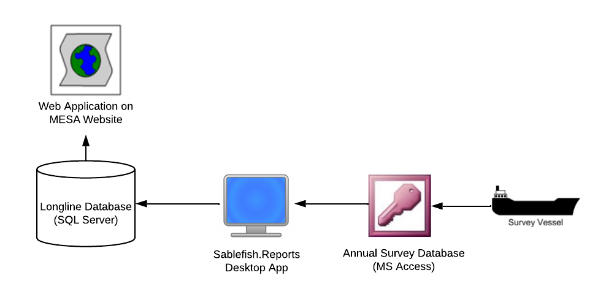
Figure 1 - Logical Architecture
The longline database and the web application are physically hosted in the Seattle data center at the Alaska Fisheries Science Center (AFSC). The annual survey data is collected and processed in Alaska by staff at the Auke Bay Lab (ABL). During the year, data is managed by staff in Juneau in a dev/test instance of the database also physically hosted in Seattle. Once a year, results of the survey are collected in copies of the annual survey database (MS Access) and loaded into the dev/test instance of the longline database using Sablefish.Reports. The survey data is validated and cleansed, and then the production database is updated using a backup-and-restore process performed by the database administrator in Seattle.

Note from Rick (10/21):
Current development: Server Name: akc0ss-vi-071.nmfs.local, IP Address: 161.55.120.71, 1919, Port: 1919

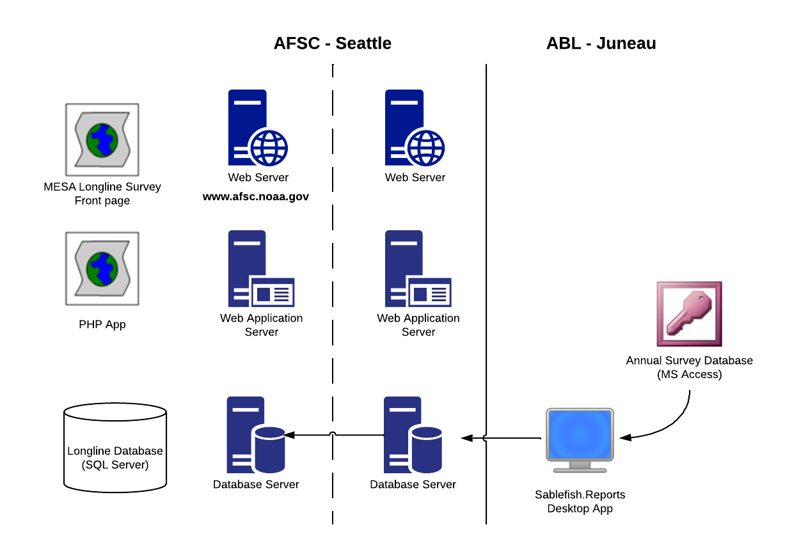
Figure 2 - Physical Architecture

Annual Maintenance Tasks
The following sections provide a list of data processing tasks that need to be accomplished each year to maintain the longline survey database.

Prepare Annual Survey Database
Before the survey begins for the year, a new copy of the annual survey database (MS Access) is created to collect data during the survey.
  - The Access database that is used at-sea is imported into
“Longline” using sablefish.reports.exe. The following tables will be imported: Haul_positions
  - Depth
  - Catch
  - Length
- Confirm that data from the experimental leg of the survey is not in the Access database to be imported.
- In each of the following tables: Haul_position, Depth, Catch, Length, set the default values for the Vessel and Cruise columns to appropriate values for the current year.
- Verify the contents of the Species, [Sppcode Catch], and [Sppcode Length] tables. If any species codes have been added or modified since last year, be sure to make corresponding updates to these tables. This must be the SQL Longline database and in Access.
- Verify the contents of the Stations table. If any stations have been added or modified since last year, be sure to make corresponding updates to these tables in the SQL Longline database.

Validate Annual Survey Database
Periodically during the survey and once after the survey is completed,
run the Check Queries (2.1.1) in the annual survey database (MS Access) to pre-validate the integrity of the survey data before import into the host SQL Server database. Run each check query and for each one, verify that either no rows are returned or that any rows returned have an explanation. For any unexplained rows, correct or delete the invalid data in the annual survey database.

Import Annual Survey Data using Sablefish.Reports
After the check queries have been run and any adjustments made to the raw survey data, import the data to the host database using Sablefish.Reports. In sablefish.reports.exe browse to the Access database to import choose the appropriate cruise number. Documentation on sablefish.reports settings can be found in I:\Longline Survey\Sablefish.Reports. The current version is RDI_R_GUI_Documentation_v3.
Look in “Bad” data tables in SQL to see if any data was not imported. This is done so that import does not quit when there is a data issue. Fix this data and import manually. If you run the Import program again it will delete the whole year and start again.

Update Whale Depredation Information
For any skates where whale depredation was known to compromise the integrity of the data from the skate, set the Whale Depredation (2.4.4.1) flag on the corresponding Depth records. For example:
- Bring in a list of whale depredated skates into MS Access as a table.
- Link to Depths, Haul_positions, Cruise_stations, Stations, and Cruises in the host SQL database.
- Create relationships between Depths, Haul_positions, Cruise_stations, Cruises, and Stations.
- Link the new killer whale depredation table with depths (through hachi), Cruises (with vessel_number and cruise_number), and with stations (station_number).
- In the query window in MS Access, run an update query where depredation_type (in the depths table) is updated to “K”. This changes all depredation_type values for all hachis in the new table from NULL to “K”.
Sample SQL
Run select before update to see record count
update depths
set rpn_filter = 'k'
FROM dbo.Cruise_Stations INNER JOIN dbo.Cruises ON dbo.Cruise_Stations.Cruise_ID = dbo.Cruises.Cruise_ID INNER JOIN dbo.Stations ON dbo.Cruise_Stations.Station_ID = dbo.Stations.Station_ID INNER JOIN dbo.Haul_positions ON dbo.Cruise_Stations.Cruise_Station_ID = dbo.Haul_positions.Cruise_Station_ID INNER JOIN dbo.Depths ON dbo.Haul_positions.Haul_Position_ID = dbo.Depths.Haul_Position_ID
WHERE(dbo.Stations.Station_Number = 4) AND (dbo.Depths.hachi > 0) AND (dbo.Cruises.Year = 2011)

--update marine mammal sightings, example
update Haul_positions
set mammal_sighting = 'S'
FROM dbo.Cruises INNER JOIN dbo.Cruise_Stations ON dbo.Cruises.Cruise_ID = dbo.Cruise_Stations.Cruise_ID INNER JOIN dbo.Haul_positions ON dbo.Cruise_Stations.Cruise_Station_ID = dbo.Haul_positions.Cruise_Station_ID INNER JOIN dbo.Stations ON dbo.Cruise_Stations.Station_ID = dbo.Stations.Station_ID
WHERE(dbo.Cruises.Year = 2011) and (dbo.stations.Station_Number in(66, 67, 68, 71, 72, 84, 85, 86, 90, 91, 93, 95, 96, 97, 98, 99, 100, 101, 102, 104, 105, 106, 108, 142, 143, 148, 149))

--update sperm whale depredation, example
update Haul_positions set Depredation_flag = 1
FROM dbo.Cruises INNER JOIN dbo.Cruise_Stations ON dbo.Cruises.Cruise_ID = dbo.Cruise_Stations.Cruise_ID INNER JOIN dbo.Haul_positions ON dbo.Cruise_Stations.Cruise_Station_ID = dbo.Haul_positions.Cruise_Station_ID INNER JOIN dbo.Stations ON dbo.Cruise_Stations.Station_ID = dbo.Stations.Station_ID WHERE(dbo.Cruises.Year = 2011) and (dbo.stations.Station_Number in(84,90,91, 93, 96, 99, 100, 101, 102, 104, 105, 106, 108, 143))

Calculate CPUE, RPNs, and RPWs
Note: This section was updated in 2021 to reflect a major upgrade to the CalcRPW script. After this update, all summary CPUE, RPN and RPW calculations are performed solely by the R script and can no longer be reproduced using the “materialized views” approach.
Once all annual survey data has been imported and verified, the CPUE, RPNs, and RPWs should be calculated using the CalcRPW R script described in section 2.7.1. This script can (and should) be used to calculate these values for a single year. This script replaces an approach developed earlier to calculate these values for all years, referred to as the “materialized views” approach. To run calcRPW use sablefish.reports.exe.
Run ACL script in sablefish.reports.exe as well before data in extracted to go to AKFIN. (NOTE: As of 2021, sablefish.reports has been updated to automatically run the ACL script after calcRPW finishes.)

Refresh Web Database
After calculating CPUE, RPNs, and RPWs, notify the database administrator in Seattle to restore the database on the production server supporting the public web application with a backup from the dev/test server containing the latest data.

Refresh AKFIN Data Warehouse
Extract the data sets and send them to AKFIN to update their data warehouse of survey data using the AKFIN Extract scripts described in section 2.8.

Data will appear as CSV files as they are being created into the same folder.
After the data is extracted, move it to the network for archive. This archive should then be compared to next year’s AKFIN export data to make sure there we no changes to the RPNs and RPWs in any years. Discrepancies could occur if raw data or area sizes were changed and CalcRPW was run again for that year, or if data was changed in areaefforts fixed, or other changes such as length weight relationships.

Send Annual Catch Limit Data to AKR
Run the ACL (Annual Catch Limit) script described below in section 2.7.3, extract the data for the new year from the TotalCatchWeight table and send it to the Alaska Regional Office for import in the region’s database.
It also extracts with the AKFINExtractBCP.
\\nmfs.local\AKC-ABL\MESA\Longline survey\Sablefish.Reports\sablefish.reports.exe

Prepare Cruise Report Data
See folder I:\Longline survey\Sablefish.Reports\Sablefish.Reports.exe.
for GUI created by RDI to run cruise report, CalcRPW, and ACL R scripts. The documentation is in the same folder.

Run the CruiseRpt script described below in section 2.7.2 and deliver the output files to be incorporated in the annual Cruise Report. See the GUI documentation for details.

Technical System Documentation

Annual Survey Database
The Annual Survey Database is an MS Access database providing a temporary data storage mechanism for collecting survey data at sea. It contains four core tables representing the survey data:
- Haul_position
- Depth
- Catch
- Length

Check Queries
The Annual Survey Database contains a set of “check” queries which can be used to pre-validate survey data before import into the host database. Each query is designed to check for certain specific anomalous values and return the rows containing them.
Check Query | Description
Check_CatchHachiNumber | Returns catch records with a hachi number greater than the threshold (200).
Check_CatchVsNumHooks | Returns skates where the total of catch + ineffective hooks + baited hooks is greater than the total number of hooks per skate (45).
Check_DepthHachiNumber | Returns depth records with a hachi number is greater than the threshold (200).
Check_DepthRange | Returns depth record with either a depth or interpolated depth is greater than the threshold (1500).
Check_HaulDate | Returns haul records where the haul date is not between the configured survey dates set in the Settings table.
Check_HaulDistanceFished | Returns haul records where the distance fished is greater than the threshold (50).
Check_HaulGearTemp | Returns haul records where the gear temp is outside the threshold (<0 or >= 15)
Check_HaulLatLon | Returns a list of hauls whose start position or end position is more than 10 nautical miles from the station position as reflected in the Stations table. Uses a Visual Basic VB method (GetDistance) embedded in the database to calculate great circle distance.
Check_HaulSoakTime | Returns a list of hauls whose soak time is outside the threshold (<0 or >=1000).
Check_HaulStartDepth | Returns a list of hauls whose start depth is outside the threshold (<0 or >=1500).
Check_HaulSurfaceTemp | Returns a list of hauls whose surface temp is outside the threshold (<0 or >=20).
Check_LengthRange | Returns a list of length records whose length is outside the threshold (<0 or >=500).
Check_LengthStratum | Returns a list of length records whose stratum is outside the threshold (0 or >= 8).
Check_LengthVsIntrpdep | Returns a list of depth records whose interpolated depth is not between the start depth and end depth of the stratum for the depth record as represented in the DepthStratum table.

Importing data from Access to SQL
This is now used to import survey data from Access. We no longer use LSImport (this update was done in October 2014).
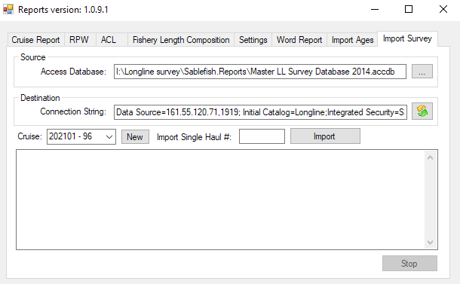
- Navigate to the most recent Access DB saved on under MESA (above is mapped to the I drive).
- The destination string should be the longline database on the development server.
  - Data Source= Data Source=161.55.120.71,1919; Initial Catalog=Longline;Integrated Security=SSPI;Connect Timeout=30
- The cruise will be the current year. A new cruise will need to be created if there is no data in SQL yet for that cruise. The vessel is 96 for AK Leader (even years) and 81 for the Ocean Prowler (odd years).
- There is a choice to import just a single haul of data.

Creating a Linked Access Database
An alternative to using SQL Server Management Studio (installed with SQL Server Express 2005) for creating ad hoc queries or directly editing system data is to create a local MS Access database with linked tables to the production Longline_Survey database. Doing so requires that an ODBC Data Source name first be configured on the local machine.
To create an ODBC Data Source to the Longline_Survey database:
- Select Start → Control Panel → Administrative Tools → ODBC Data Sources. Select the System DSN tab:
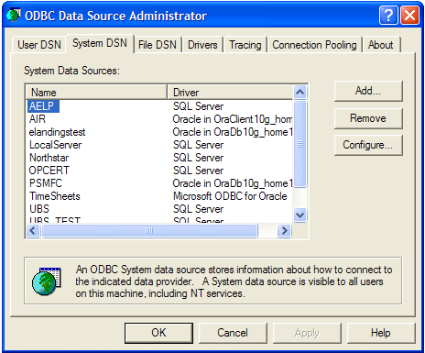
- Click Add, then Next, then select the SQL Server driver:
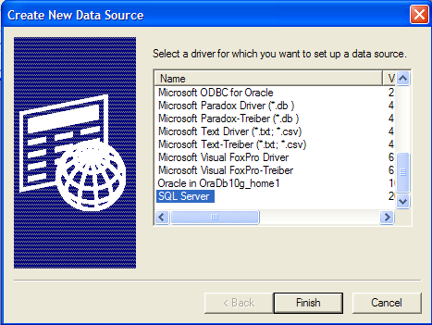

- Enter a Name and Description (e.g. “Longline_Survey”) for the database and specify the server for the production database.
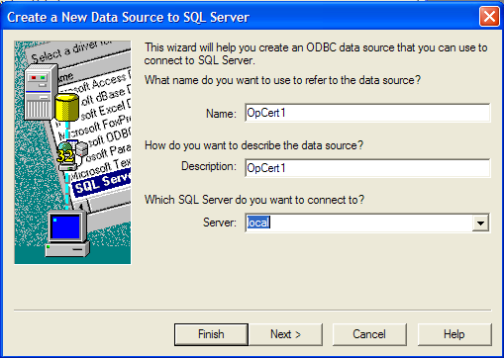
- Choose Windows Authentication and click Next:
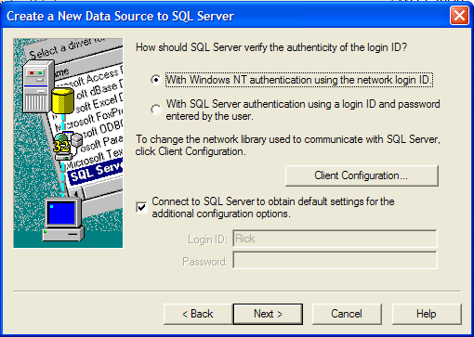

- Change the Default database to Longline_Survey:
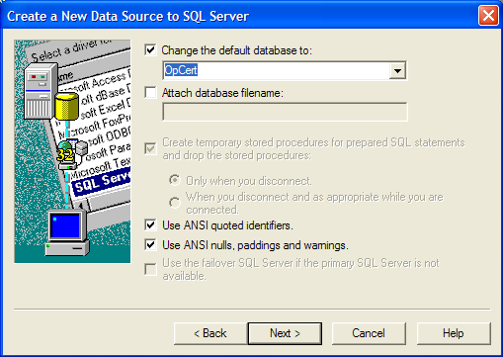
- Click Next, then Finish, then Test Data Source to verify.
Once a Data Source Name has been created, create an MS Access database, and link to the desired tables as follows:
- Choose to create a linked table.
- When prompted for the Data Source, select the Machine Data Source tab, and select the Data Source created above.
- Select the desired tables to link from the list provided in the dialog and click OK.
- If linking to a view, you will be prompted to select a column or columns to represent the unique record identifier. Make sure you understand which column or columns comprise the unique identifier in the source view (i.e. the most specific row identifier in the list) and be sure to select the correct column or columns when prompted to avoid unpredictable results.

Data Model
The Longline Survey Database consists of about 26 tables, most of which are code tables. For the purposes of this documentation, the tables are grouped into the following subject areas:
- Code Tables
- Vessels, Cruises, and Stations
- Core Survey Data

Identity Columns
All tables in the database include an internal integer Identity (ID) column automatically generated by the database on inserts of new records. The ID columns are typically named with the following pattern: <entity_name>_ID, e.g. “Station_ID”. Care should be taken not to confuse these ID columns with “historical “number” columns which are typically named with the following pattern <entity_name>_Number, e.g. “Vessel_Number”. In general, foreign key relationships between related tables in the database will be implemented using the identity columns. Data users, however, will tend to access specific records in the database using the historical number columns. The historical number columns represent the numbers which were recorded in paper logbooks and coded into the polycorders used to capture survey data.

Code Tables
In general, the code tables consist of a numeric Id or alpha-numeric code as the primary key and a corresponding name or description. These tables function as lookup tables providing constraints on allowable values for certain core table attributes. The following table lists all code tables in the database.
Table | Description
Areas | Represents area designations at the level of resolution recorded on Stations (Geographic Areas). See Areas below.
Bait_Types | Represents types of bait used on skates.
Council_Management_Areas | Represents area designations at the council management area level of resolution.
Council_Sablefish_Management_Areas | Represents area designations at the council sablefish management area level of resolution.
Depredation_Types | Represents types of mammal depredation (e.g. sperm whale, killer whale, etc.) occurring during a haul.
Depth_Stratum | Represents depth strata used to summarize catch and length data.
FMP_Management_Areas | Represents area designations at the Fisheries Management Plan area level of resolution.
Gear_Types | Represents types of gear used.
Geographic_Areas | Represents area designations at the geographic area level of resolution.
Habitat_Types | Represents types of habitat.
INPFC_Areas | Represents area designations at the INPFC area level of resolution.
Regions | Represents regional divisions.
Specie_Catch_Codes | Represents codes (RACE) used to identify the species on survey data sets. In this table there are growth parameters for species we length as well as species specific ratios used to extrapolate western AI RPN/RPWs
Station_Types | Represents the type of a station (i.e. Standard vs. Experimental)
Sex | Represents the sex of a fish, e.g. 1 = ‘M’ale, 2 = ‘F’emale, or 3 =‘U’nknown.
Maturity | Represents the maturity of a fish, e.g. immature, adult, etc.

Areas
A number of the code tables are designed to represent multiple “layers” of area designations defined by different management regimes. The Areas table functions as the primary area lookup table for Stations and provides a translation between the “Geographic Areas” used for stations and the other area designations. The Exploitable flag on the Areas table is used to filter areas for the summary data that will be displayed on the web and for the RPN/RPW calculations. Only data for stations in areas whose exploitable flag is true will be displayed. Experimental stations within these areas are not used for RPN/RPWs (see 2.4.3).
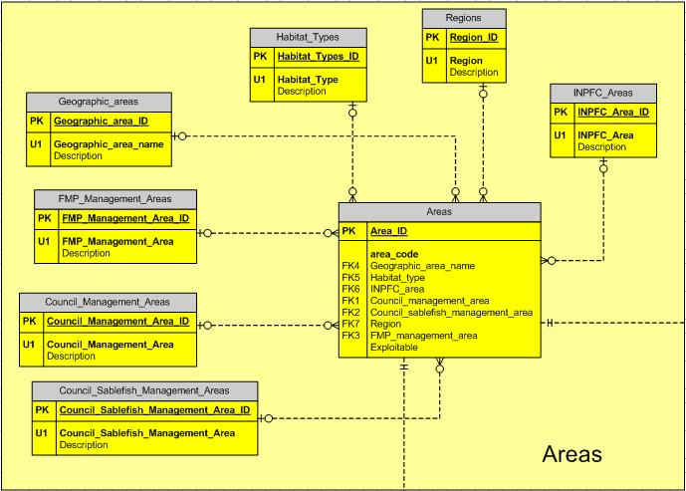
Figure 3 - Areas

Species_Catch_Codes
The Species_Catch_Codes table represents RACE species codes used to identify species in the core survey data tables. This table also has a Polycorder_Number column providing a translation between the RACE codes and the numbers assigned to the species on the polycorders used during the at-sea survey activities. For a small set of species, a_vonBert and b_vonBert represent constants used in the growth functions used to estimate weight from length for RPW calculations and calculations of mean weight. The avg_weight column stores an average weight estimate for the species calculated from NMFS trawl surveys. This value is used to estimate average weights in support of the Annual Catch Limit (ACL) reporting for species where growth parameters are not known or not available. The web_reporting_flag is used to filter summary results for the web application. Only data for species whose web_reporting_flag = true will be displayed in the web application. The NW_AI_ratio and SW_AI_ratio are used to extrapolate current eastern AI RPNs and RPWs to the western AI areas. These values are ratios of RPNs for years when Japan sampled both areas (1985-1994). The ratio was calculated for each species. The ratio for sablefish is hard-coded and was not calculated, so as not affect the time series of data that has already been published. The survey_species_flag is used to filter species that will appear is the catch_WNulls view, which provides catch data as well as effort data even when there was no catch. This flag was created so that catch_Wnulls would not be unreasonably large. This flag is also used by the CPUE, RPN, and RPW calculations for the same purpose. Only species where this flag is set to true will be included in those calculations.

Vessels, Cruises, and Stations
A Sablefish longline survey is conducted each year by one or more Vessels at a number of Stations throughout the Bering Sea, Aleutian Islands, and Gulf of Alaska.
The Vessels table functions as a lookup table and includes rows for each vessel that has participated in the longline survey. It represents the name of the vessel (Vessel_name) and the Country the vessel is from. The survey was conducted by Japanese vessels from 1979 to 1987. Between 1988 and 1994, both U.S. and Japanese vessels conducted the survey together. After 1994, responsibility for the survey was completely turned over to the U.S.
An annual survey for an individual Vessel is represented by a Cruise. The Cruises table stores the Vessel Number, the Year of the cruise, an optional description, and the historically used cruise number for the cruise (Cruise_Number). There is at most one Cruise per Vessel and Year.
The Stations table represents locations at sea where the survey is conducted. The table stores the historical number for the station (Station_Number) an optional description, and an Active flag indicating whether the station is currently part of the annual survey. Each station has a Station Type of either Standard or Experimental. Standard stations are used each year (or every other year) for the survey and their data is included in effort and abundance calculations. Experimental stations represent special survey locations where survey activities were conducted in non-standard ways for any variety of reasons. Experimental station data is NOT included in effort and abundance calculations (RPN and RPW’s) or length frequency calculations. A Station may be Standard, but not Active, if it used to be part of the standard survey (and is therefore still valid for historical effort and abundance summaries) but is no longer part of the current annual survey.
The Cruise_Stations table is an intersection table between Cruises and Stations. It represents all of the stations that were used for each cruise.
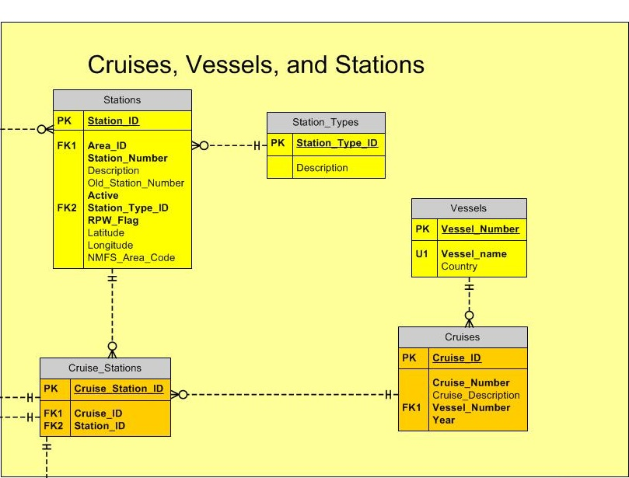
Figure 4 - Cruises, Vessels, and Stations

Core Survey Data
The core survey data is represented by the following tables:
- Haul_positions
- Depths
- Catches
- Lengths
- Ages
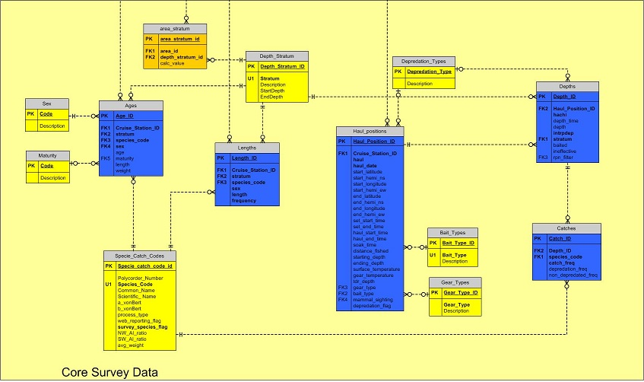
Figure 5 - Core Tables

Whale Depredation
The Depths table includes an rpn_filter field that represents whether the validity of the skate data was compromised by killer whale, other mammal depredation activity, or gear not fishing effectively. Records having a non-null value for depredation_type will be excluded from CPUE, RPN, and RPW calculation.
The Haul_positions table has a mammal_sighting field which is specific to the haul. It is used mainly to flag hauls for the presence of sperm whales when retrieving gear. The depredation_flag field is used to flag a haul for the presence of sperm whale depredation. This is not used to exclude data from RPN calculations. The Depredation_Types table defines the codes used for these fields as well as rpn_filter. In catches, total catch is available (catch_freq) is broken down into depredated catch and non-depredated catch; the separating of the catch into 2 categories started in 2010. If the fish was not identifiable and was depredated, the depredated fish species code will be used and the catch will appear under the depredated catch column.

Maintaining Stations, Cruises, and Hauls

Changing the Station for a Haul
There may be a reason to change the station number associated with one or more hauls. Historically, this has been done, for example, when it was determined that the hauls represented experimental activity that should not be associated with the standard station originally reported for the haul. Because haul data is not directly tied to station records, changing the station for a haul or set of hauls is a multi-step process:
- Identify or create a new station record.
If the station already exists, then look it up in the Stations table and note the Station_ID. If the station does not already exist, then create a new record in the Stations table (see Adding a New Station below) and again note the new Station_ID value generated by the database after the record is inserted.
- Insert new or update the existing Cruise_Station record for the haul(s) with the new Station_ID.
  - First lookup the haul records to be changed in the Haul_positions table and note the Cruise_Station_ID(s) for the haul(s).
  - If ALL the haul records for the Cruise_Stations records identified by ID in the previous step (a) will be assigned to the new station, just note the Cruise_Station_ID(s) for update in the following step (c). If only SOME of the haul records will be associated to the new station, create a new Cruise_Stations record for the existing Cruise and new Station (see Adding a New Cruise Station below).
  - If just updating Cruise_Stations records, for each distinct Cruise_Station_ID, find the corresponding record in the Cruise_Stations table and update the Station_ID value for it with the Station_ID identified in step 1.
  - If a new Cruise_Stations record was added to be associated with just some of the hauls for the affected Cruise, then identify the Cruise_Station_ID of the new record created above (step b). Update each of the affected hauls in the Haul_positions table by setting the Cruise_Station_ID column to the Cruise_Station_ID value of the new record.
  - If a new Cruise_Stations record was added, determine whether any Lengths records should also be associated with the new Station. If so, change the Cruise_Station_ID column on those Lengths records to the Cruise_Station_ID of the new Cruise_Stations record created above.

Adding a New Station
To add a new station, open the Stations table and insert values in a new row representing the station. A new Station record has a number of required properties that must be determined before entering the new record:
- Area_ID
First lookup the area for the new station from the Areas table and note the Area_ID. If the station is being ‘copied’ from another station in the same area, lookup the other station in the Stations table and use it’s Area_ID. If the station should be included in the RPN/RPW calculations then make sure the Exploitable flag of the associated Area record is set to 1.
- Station_Number
Determine the Station_Number for the new station. Station numbers must be unique within the Stations table. Experimental stations by convention have station numbers in the 500s. If the station is experimental, choose the next highest number in the 500s, e.g.:
select max(station_number) + 1 from Stations where Station_Type = 2
If the new station is standard, choose the next highest number NOT in the 500s or any other unique number as desired.
- Old_Station_Number
If the new station is logically replacing another existing station, set Old_Station_Number to the station number of the existing station.
- Active
If the new station will be part of the list of standard annual or bi-annual survey stations in the current and anticipated future years, set Active = 1, otherwise if the station represents a one-time or otherwise non-active station, set Active = 0.
- Station_Type
Set Station_Type = 1 if the new station is or was part of the list of standard annual or bi-annual survey stations. Set Station_Type = 2 if the new station is an experimental station.

Adding a New Cruise Station
Whenever a new Station is created, a new Cruise_Stations record also needs to be created. To add a new Cruise_Stations record representing the occurrence of survey activity at a Station during a Cruise, first make sure that a record already exists for the cruise in the Cruises table, and that a record for the Station already exists in the Stations table (see Adding a New Station above). Once both records exist, simply create a new record in the Cruise_Stations table setting the Cruise_ID and Station_ID columns accordingly.

CPUE, RPN, and RPW Calculations
Historically, Catch per Unit of Effort (CPUE), Relative Population Number (RPN) and Relative Population Weight (RPW) estimations were calculated from the raw data using a Fortran program. These calculations are replaced by a collection of views and tables in the Longline Survey Database. CPUE, RPN, and RPW calculations are summarized at four different levels of aggregation listed below in order of granularity:
- Station and Depth Stratum
- Geographic Area and Depth Stratum
- Geographic Area (across all Depth Strata)
- Sablefish Management Area (across all Depth Strata)
In 2021, all database-driven calculations of CPUE, RPN, and RPW were completely replaced by updates to the CalcRPW.R script and the addition of a new calcrpw_summaries.R script. Variances, adjustments for whale depredation, and summaries at larger area aggregations were added. Updates to area sizes were also made in the database, which affect values across the entire time series output from previous versions of the CPUE, RPN, and RPW calculations. Additional larger area aggregations include:
- FMP Subarea
- FMP Area
- AK-wide
The following table and diagram illustrate the views and tables and the relationships between them that are relevant to the CPUE, RPN, and RPW calculations at the various levels of aggregation. Each view either duplicates logic that is also performed in CalcRPW or represents output from the CalcRPW process. Consult the documentation for the CalcRPW script in section 2.7.1 for more details regarding the logic encapsulated by these views.
DO NOT EDIT THESE VIEWS. DOING SO WILL COMPROMISE THE VALIDITY OF THE CPUE, RPN, AND RPW CALCULATIONS. ALSO, IF DATA IS CHANGED, DON’T RELY ON DATA PRODUCED BY THESE VIEWS UNLESS THE CalcRPW PROCEDURE IS RE-RUN.
View/Table Name | Description
TotalCatchByStratum | Summarizes total catch by station and stratum for all species, EXCEPT for Shortraker and Rougheye (SRRE) and Kamchatka and Arrowtooth (KMAR), for Standard stations where no killer whale depredation occurred (flagged with rpn_filter) and the total number of ineffective hooks on skates is between 0 and 5, inclusive (i.e., skates used for RPN/RPW calculations).
TotalSkatesByStratum | Summarizes total number of skates by station and stratum for all catch records for Standard stations where no depredation occurred and the total number of ineffective hooks on skates is between 0 and 5, inclusive (i.e., skates used for RPN/RPW calculations).
MeanWeightsByStratum | Calculates the length and average weight by station, stratum, and species using a_vonBert and b_vonBert constants when they are defined in the Species_Catch_Codes table and lengths are taken.
SRRETotalCatchByStratum | Summarizes total reported catch by station and stratum for all catch records for SRRE only, for Standard stations where no depredation occurred and the total number of ineffective hooks on skates is between 0 and 5, inclusive (i.e., skates used for RPN/RPW calculations).
SRRERates | Calculates rates of Shortraker vs. Rougheye from length records and splits reported catch of SRRE reported with the group code (30051) to the species-specific codes based on calculated rates and calculates mean length and weight by station/strata using specifies specific growth curves to calculate weight.
SRRECPUE | Calculates Station/Stratum-level CPUE, RPN, RPW, mean weights, and mean length values for all Shortraker and Rougheye. Mean weights and lengths are weighted by stratum size.
KMARTotalCatchByStratum  ADDED 2019 | Summarizes total reported catch by station and stratum for all catch records for species code 10111 (KMAR) in 2019 and later only, for Standard stations where no depredation occurred and the total number of ineffective hooks on skates is between 0 and 5, inclusive (i.e., skates used for RPN/RPW calculations).
KMARRates  ADDED 2019 | Calculates rates of Kamchatka vs. Arrowtooth from length records and splits reported catch of KMAR reported with the group code (10111) to the species-specific codes (10110 – Arrowtooth, and 10112 - Kamchatka) based on calculated rates and calculates mean length and weight by station/strata using specifies specific growth curves to calculate weight.
KMARCPUE  ADDED 2019 | Calculates Station/Stratum-level CPUE, RPN, RPW, mean weights, and mean length values for all Kamchatka and Arrowtooth. Mean weights and lengths are weighted by stratum size.
CPUE | Calculates Station/Stratum-level CPUE, RPN, and RPW values for all species EXCEPT for Shortraker and Rougheye and Kamchatka and Arrowtooth. Mean weights and lengths are weighted by stratum size. Lengths and weights are available only for species that are were lengthed and have growth curve parameters.
StationEffortsView | Unions SRRECPUE, KMARCPUE, and CPUE to produce all Station/Stratum-level CPUE, RPN, and RPW values. From here on when mean weight is calculated it is not averaged as length is, it is always calculated using the a and b parameters in specie_catch_codes.
StationEffortsExtrapView | Extrapolates CPUE, RPN, and RPW values for strata that are missing area size information. Extrapolates for strata 6 in areas 142 and 143 and for stratum 5 in areas 144 and 145 from adjacent stratum data in those same areas. Includes data from the StationEffortsView as well as extrapolated data.
StationEfforts  StationEfforts_depred | Represents the output of StationEffortsExtrapView. Since 2021, this table is populated by the CalcRPW script. StationEfforts_depred contains data for Sablefish only adjusted for whale depredation.
AreaStratumRPN  AreaStratumRPN_depred | Summarizes CPUE, RPN, and RPW indices by depth stratum to the geographic area level. Replaces table previously named “AreaStratumEfforts”. Populated by CalcRPW since 2021. AreaStratumRPN_depred contains data for Sablefish only adjusted for whale depredation.
AreaRPN_3to7  AreaRPN_3to7_depred  AreaRPN_AllStrata  AreaRPN_AllStrata_depred | CPUE, RPN, and RPW indices summarized over depth stratum to the geographic area level. “3to7” versions only include data from depth strata 3-7, while “AllStrata” versions include data from stratum 2. “depred” versions only include Sablefish, adjusted for whale depredation. Replaces table previously named “AreaEfforts”. Populated by CalcRPW since 2021.
AreaEffortsFixed | Table duplicating structure of the AreaRPN_* tables and including hard-coded summary data published in historical years for sablefish (Japanese surveys), but for which original source data is corrupted or no longer available. CalcRPW uses this table to populate AreaRPN_* tables above replacing calculations with hard-coded values from this table where they exist.
MeanLengthsByAreaStratum | Summarizes mean lengths and weights at the Area/Stratum-level from the StationEffortsExtrapView and scaled by CPUE, for those species that have growth constants set in the Species_Catch_Code table. Extrapolates for records for Western AI so it can be joined with AreaEffortsView below to calculate estimates using ratios stored in the Specie_Catch_Code table.
Lengths_View | Joins Length table to Station, Cruise, Vessel, Area, and Species_catch_codes tables to report related data with Length frequencies (i.e. number of fish caught by station/stratum/length).
LengthFrequenciesAveragesView | Calculates average length-frequency-per-station for each species and observed length by FMP Area
LengthFrequenciesAvgsByStratumView | Uses LengthFrequenciesAveragesView and LengthFrequenciesByStratumView to calculate RPN-weighted average length frequencies based on average FMP-wide length-frequency-per-station values to fill in blanks in LengthFrequenciesByStratumView where catch exists, but no lengths were taken for a species in a given geographic area and stratum
LengthFrequenciesByStratumView | Calculates RPN-weighted average length frequencies for each species, sex, length, geographic area, and depth stratum where both catch and lengths of a given species are recorded.
LengthFrequenciesGulliesViews | Produces all raw lengths from Lengths_View and extrapolates lengths at gully stations 142 – 146 at depth strata that are not fished in those stations.
LengthFrequenciesView | Combines output from LengthFrequenciesByStratumView and LengthFrequenciesAvgsByStratumView and sums over depth stratum to provide a unified estimate of RPN-weighted average length frequencies by geographic area.
LengthRPN_byArea_3to7  LengthRPN_byArea_3to7_depred  LengthRPN_byArea_AllStrata  LengthRPN_byArea_AllStrata_depred | Length-based RPN and RPW indices summarized over depth stratum to the geographic area level. “3to7” versions only include data from depth strata 3-7, while “AllStrata” versions include data from stratum 2. “depred” versions only include Sablefish, adjusted for whale depredation. LengthFrequencies_byArea_AllStrata should produce same results as LengthFrequenciesView. Populated by CalcRPW.
CouncilSablefishArea_3to7  CouncilSablefishArea_3to7_depred  CouncilSablefishArea_AllStrata  CouncilSablefishArea_AllStrata_depred | Catch-based CPUE, RPN and RPW indices summarized to the Council Sablefish Management area level. “3to7” versions only include data from depth strata 3-7, while “AllStrata” versions include data from stratum 2. “depred” versions only include Sablefish, adjusted for whale depredation. Populated by calcrwp_summaries.R.
CouncilSablefishAreaFixed | Hard-coded US data for Sablefish in the BS between 1990 and 1997. Used by calcrpw_summaries.R to override calculated values into CouncilSablefishArea_*.
FMPSubarea_3to7  FMPSubarea_3to7_depred  FMPSubarea_AllStrata  FMPSubarea_AllStrata_depred | Catch-based CPUE, RPN and RPW indices summarized to the FMP Subarea level. “3to7” versions only include data from depth strata 3-7, while “AllStrata” versions include data from stratum 2. “depred” versions only include Sablefish, adjusted for whale depredation. Populated by calcrwp_summaries.R.
FMP_3to7  FMP_3to7_depred  FMP_AllStrata  FMP_AllStrata_depred | Catch-based CPUE, RPN and RPW indices summarized to the FMP level. “3to7” versions only include data from depth strata 3-7, while “AllStrata” versions include data from stratum 2. “depred” versions only include Sablefish, adjusted for whale depredation. Populated by calcrwp_summaries.R.
AK_wide_3to7  AK_wide_3to7_depred  AK_wide_AllStrata  AK_wide_AllStrata_depred | Catch-based CPUE, RPN and RPW indices summarized for all of AK. “3to7” versions only include data from depth strata 3-7, while “AllStrata” versions include data from stratum 2. “depred” versions only include Sablefish, adjusted for whale depredation. Populated by calcrwp_summaries.R.
AKwideFixed | Hard-coded Japanese RPN and RPW estimates (no variances) for Sablefish between 1979 – 1994 Alaska-wide. Used by calcrpw_summaries.R to override calculated values into AK_wide_*.
WebAreaView | Produces CPUE, RPN, and RPW data from the CouncilSablefishArea_3to7 view representing indices at the Sablefish Management Area level (NPFMC areas) for display in the web application on the AFSC web site. For US survey data after 1996, data for the Bering Sea and Aleutians is extrapolated in alternate years from adjacent years that the area was sampled and the current trend in the GOA. Only data from stations in areas whose Exploitable flag is set is included.
WebStationView | Summarizes total catch, mean length, and mean weights by Station for display in the web application. This view is “materialized” to the WebStations table. This view is not used in the CPUE/RPN/RPW calculations at all and therefore does not appear in the diagrams below.

The following diagrams illustrate dependencies between the core views listed in the above table.

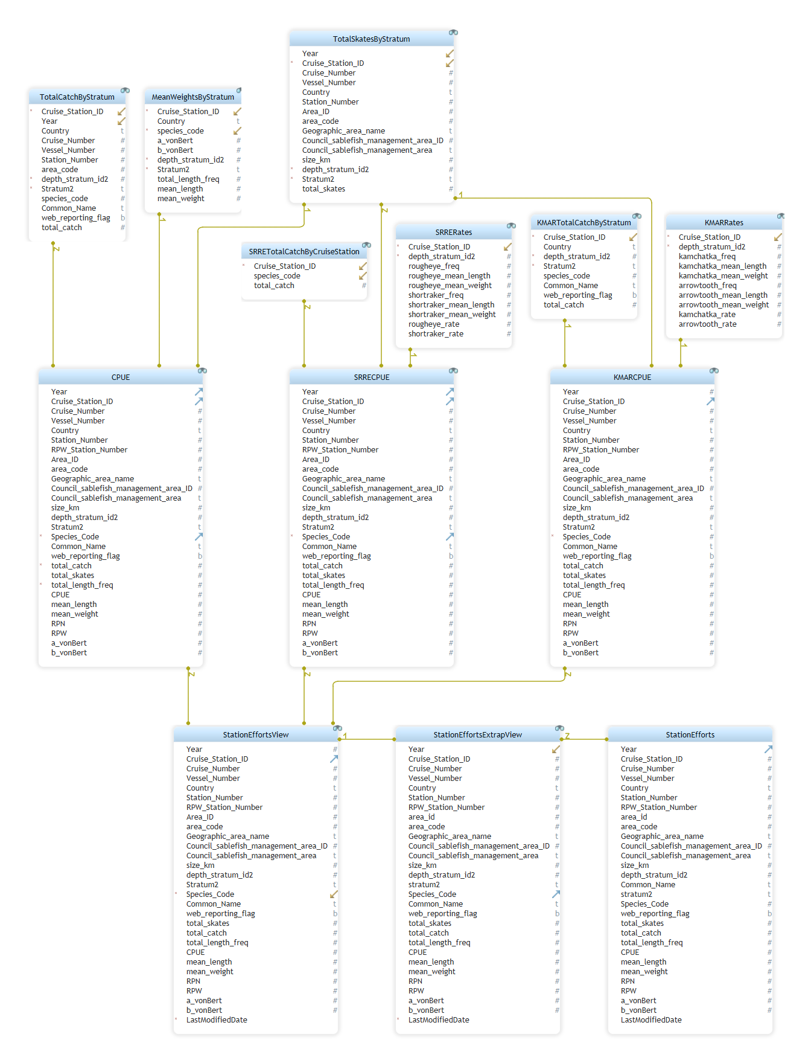Figure 6 - Station Efforts Views
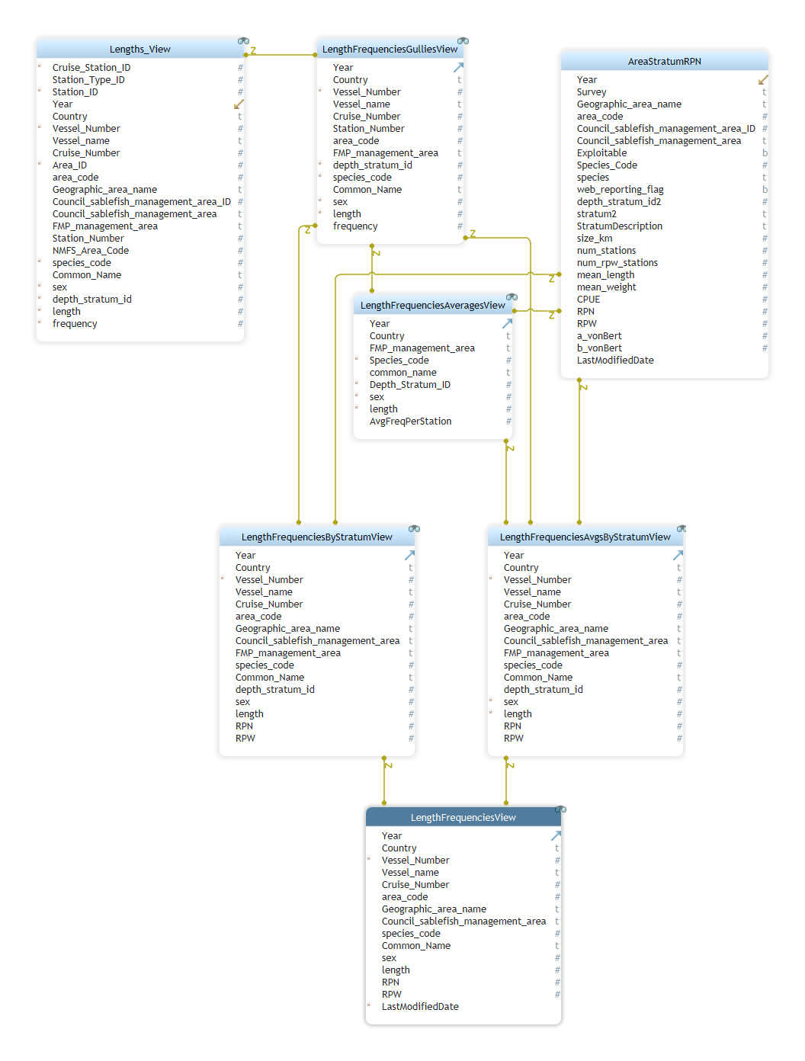Figure 7 - Area Stratum RPN and Length Frequencies Views

Materialized Views
The Materialized Views approach and spMaterializeViews procedure were dropped in 2021.

R Scripts

CalcRPW
The CalcRPW script calculates CPUE, RPNs, and RPWs for a year of survey data. It replaces the collection of views and the spMaterializeViews stored procedure described above in section 2.6. It performs the same logic as the views used to, but does so in procedural R code, and does not rely on any of the views that were once used by spMaterializeViews.
The CalcRPW script reads Catch, Depth and Length data from the Longline Survey database and inserts its results back into the database into multiple versions of the following tables as described in more detail in the table under section 2.6 above:
- StationEfforts*
- AreaStratumRPN*
- AreaRPN*
- LengthRPN*
A companion script: calcrpw_summaries, added in 2021, uses the results from CalcRPW to produce summaries at larger geographic area definitions into the following sets of tables, also described in more detail in section 2.6 above:
    - CouncilSablefishArea*
    - FMPSubarea*
    - FMP*
    - AKwide*
The CalcRPW script was originally developed primarily as a performance enhancement. In 2021, it was enhanced to calculate variances for CPUE, RPN, and RPW calculations and also to incorporate adjustments for whale depredation that are not calculated anywhere else within the database. The following sections describe some of the details of the calculations performed by the CalcRPW script.
Using the RDI GUI interface (\\nmfs.local\AKC-ABL\MESA\Longline survey\Sablefish.Reports) you can choose to run the CalcRPW script and export data as CSV files or directly into the Longline SQL database. After CalcRPW has been run, calcrpw_summaries can be run to export summaries at larger area groupings. Note that the export of WebStations and WebAreas is performed by the calcrpw_summaries script. The CalcRPW script processes a single year of data. The calcrpw_summaries script operates on all data in the time series.

Logic Flow
The following diagram illustrates the logic flow of calculations performed by the CalcRPW script:
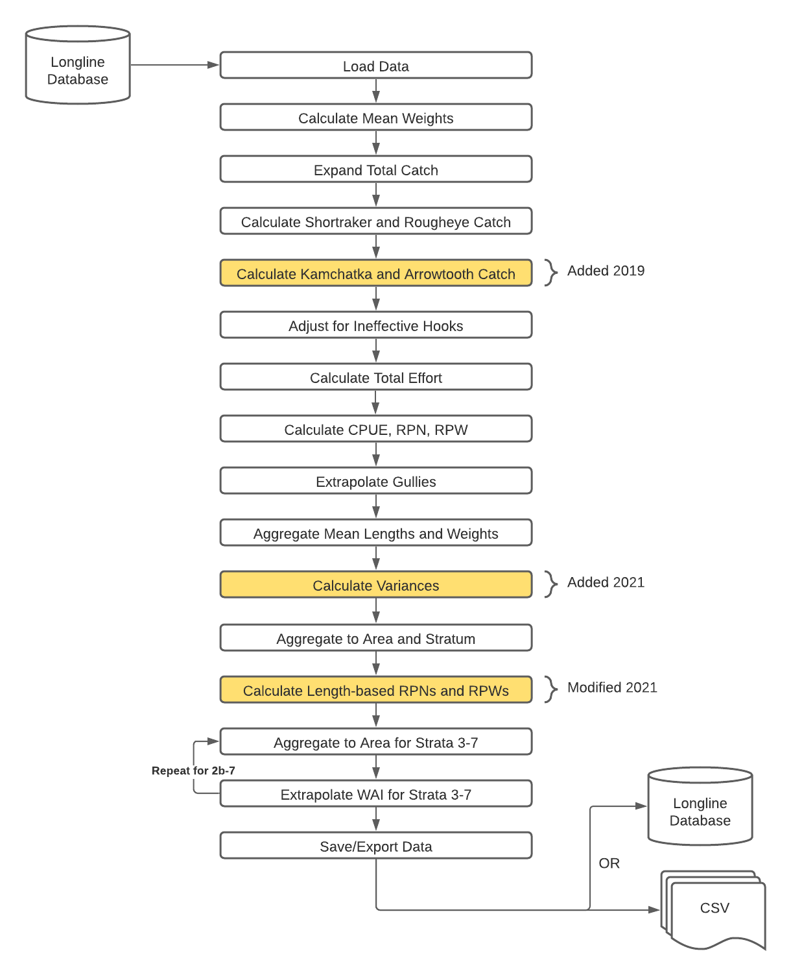

Load Data
The script loads data from the Longline database using an ODBC data source from the following views and tables:
- Catches_View
- Lengths_View
- Specie_Catch_Codes
- Area_Stratum
- Depth_Stratum
- Areas
- Vessels
It loads all raw catch and length data for a given year, filtered as follows:
- Catch records are only included for skates where ineffective hooks <= 5.
- Only catch and length data from Standard (non-experimental) stations are included (Station_Type_ID = 1).
- Catch records from skates where killer whale depredation was recorded (rpn_filter is not null) are excluded.
- Length records where length frequency = 0 and the stratum is unknown (stratum = 0) are excluded.
- Since 2021, only data for species labeled as “variance” species are included. At the time of this writing, the lists are as follows, for US and Japan, respectively:
US Variance Species
20510 Sablefish
21720 Pacific cod
21230 Giant grenadier
10120 Pacific halibut
10110 Arrowtooth flounder
30020 Shortspine thornyhead
320 Pacific sleeper shark
21220 Pacific grenadier
310 Spiny dogfish
30470 Yelloweye rockfish
10115 Greenland turbot
30050 Rougheye rockfish
30576 Shortraker rockfish
440 Longnose skate
455 mud skate
475 commander skate
480 whiteblotched skate
10112 Kamchatka flounder
99995 Aleutian/Bering/Alaska Skate Complex

Japanese Variance Species
310 Spiny dogfish
10110 Arrowtooth flounder
10115 Greenland turbot
10120 Pacific halibut
20510 Sablefish
21220 Pacific grenadier
21230 Giant grenadier
21720 Pacific cod
30020 Shortspine thornyhead

Calculate Mean Weights
CalcRPW calculates the mean weights for all species that are lengthed and for which growth factors are known, grouped by station, stratum, and species.
The raw length data (before summarization to station, stratum, and species) is joined to the growth factors (a_vonbert, b_vonbert) associated with survey species. For each length value recorded, a unit weight is calculated as:
unit_weight = a_vonbert * length ^{b_vonbert}
Where unit_weight = the individual fish weight. Then the length and weight data is summarized by station, stratum, and species and mean lengths and weights are calculated as:
mean_length_{i} = sum(length_freq_{ij} * length_{j}) / sum(length_freq_{i})
mean_weight_{i} = sum(length_freq_{ij} * unit_weight_{j}) / sum(length_freq_{i}),
where mean_length_{i} = the mean length for the i^{th} station, strata, species. Length_freq_{ij} is the number of lengths within the i^{th} station, strata, and species and the j^{th} length. Length_{j} is the length category in cm. Length_freq is the sum of the number of lengths for the i^{th} station, strata, and species. Mean weight follows the same formula.

Expand Total Catch
Total catch is read from the database with rows corresponding to each skate and species where catch was recorded. The data is read from Catch_View which is constructed so that there is always at least one row for every skate, even if no catch was recorded at a skate. This step extracts the unique skates from the catch data and cross joins it by the list of species to generate a matrix containing a row for every station, skate, and species regardless of whether there was any catch of the species on the skate. This results in positive reporting of 0 amounts for all species where no catch was recorded (i.e., one row for each species for each skate regardless if it was caught or not.)

Calculate Shortraker and Rougheye Catch
Because it is difficult to distinguish between Shortraker and Rougheye rockfish at the time catch is captured at sea, catch of Shortraker and Rougheye (SRRE) are combined as one species code the database (Catch_View and catches table). The US Survey has used 30051 as the group species code since 1998, but used 30040 as the group code before 1998. This group code included some other rockfish as well, but they are not a predominate species.
In the U.S. survey, species are identified to Shortraker or Rougheye during the lengthing process and length frequencies are calculated (i.e. the number of fish caught by species) for each individual species code (Shortraker - 30576 and Rougheye - 30050). The Japanese survey collected lengths for SR and RE in all years (1979-1994), but all length data has stratum = 0, so none of it can be used to split the catch into the individual species codes from the group code. The catch data for the Japanese survey appears to have been split (from 30040) to 30050 and 30576 in 1993 and 1994. Just 4 Rougheyes (30050) were recorded in 1992. Because, like the rest of the Japanese surveys, there is no length data associated with stratum, catch with code 30040 could not be split into SR and RE.
An estimate of the total catch of the individual species is calculated by determining a rate for each species by Station, Stratum:
SR rate = sum(SR lengths) / (sum(SR lengths) + sum(RE lengths))
RE rate = sum(RE lengths) / (sum(SR lengths) + sum(RE lengths))
These rates are then applied to the sum of catch of the group code (SRRE – 30051 or 30040 depending on the year) for each Station an Stratum:
Shortraker catch = sum(SRRE catch) * SR rate
Rougheye catch = sum(SRRE catch) * RE rate
The catch data in Catches_View are populated with these species-specific catches.
Note that catch data has been pre-filtered to exclude catch with killer whale predation (rpn_filter = 'k'), but lengths have not, so there may be cases with non-zero shortraker and rougheye rates calculated from lengths but no corresponding catch frequencies.

Calculate Kamchatka and Arrowtooth Catch

Beginning in 2019, the logic used to split catch of Shortraker and Rougheye rockfish reported with the group code for Shortraker/Rougheye was duplicated to split catch of Kamchatka and Arrowtooth Flounder reported with the group code 10111. The only difference between the logic for SRRE versus the logic for KMAR is that for SRRE, ALL catch is reported with the group code and ALL lengths are reported with the individual species codes. For KMAR, some catch is reported with the individual code for Arrowtooth (10110) and some catch is reported with the group code for Kamchatka/Arrowtooth (10111). All lengths are reported with the respective individual codes (10110 and 10112, respectively. During the calculations of splits for KMAR, only catch reported with 10111 is split and any calculated instances of 10110 are added to the amounts of Arrowtooth that were directly reported using 10110.Adjust for Ineffective Hooks
Total catch is summarized by station, stratum, and species. Catch frequencies are scaled up to the standard 45 hooks per skate to adjust for ineffective hooks:
catch_freq = (catch_freq / (45 – ineffective_hooks)) * 45

Calculate Total Effort
Total effort by station and stratum is the sum of the number of skates (from the catch data that has been expanded so that it accounts for skates with no catch) at each station and stratum.

Calculate CPUE, RPN, RPW
Having calculated total catch and total effort by station, species, and stratum, it is now possible to calculate catch per unit of effort as:
CPUE = total_catch / total_effort (i.e., number of skates)
RPN is calculated as CPUE scaled by the size (in km²) of the area at the stratum that the station is in:
RPN = CPUE * area_size
RPW is calculated as RPN scaled by the mean weight of the species at the station and stratum.
RPW = CPUE * area_size * mean_weight

Extrapolate Gullies
Typically, the survey attempts to lay the longline so that it spans all of the strata being sampled. This is not practical in certain “gully” stations.
Once CPUE, RPN, and RPWs have been calculated, an extrapolation is performed to estimate catch at 4 gully stations in strata where no fishing occurs.
At stations 142 and 143, catch at depth stratum 5 is extrapolated to stratum 6. At stations 144 and 145, catch at depth stratum 4 is extrapolated to stratum 5.
First, all catch and the CPUE at the sampled stratum is directly copied to new rows. Then RPN and RPW is recalculated as above, but using the actual area size of the un-sampled strata.

Aggregate Mean Weights and Lengths
Mean weights and lengths have been calculated by station, species, and stratum. This step aggregates the amounts by geographic area, species, and stratum (i.e., averages for all stations within each geographic area/stratum) and weights each station/strata mean length and weight by the CPUE.
First the total number of stations that exist at each area/stratum is calculated as num_stations. Then the mean CPUE for each area, species, and stratum is calculated as:
CPUE = sum(CPUE_{i}) / num_stations,
Where CPUE = CPUE for the area/stratum and CPUE_{i} = the CPUE for the i^{th} station/stratum/area.
The mean lengths (mean_length) for each area, stratum, and species is calculated by averaging the mean lengths at each station, strata, and species (mean_len), weighted by the CPUE for the area for each species:
mean_length_{i} = sum(mean_len_{ij} * CPUE_{ij}) / CPUE_{ij}
Where Mean_length_{i} is the mean length for the i^{th} area, strata, and species. Mean_len_{ij} is the mean length for j^{th} station at the i^{th} strata, area, species. CPUE_{ij} is the catch per unit effort for the for j^{th} station at the i^{th} strata, area, species.
Mean weights are re-calculated using the growth factors against the new mean_length value for the species and area/stratum:
mean_weight = (a_vonbert * mean_length ^{b_vonbert})
Finally the total number of stations that exist at each area/stratum where mean weight can be calculated (because there were lengths), are summed as num_rpw_stations for use later when aggregating mean weight to area and stratum.

Calculate Variances
Variance-covariance calculations with corrections for whale depredation were added to the CalcRPW script by Jane Sullivan in 2021. Variances for RPNs are calculated using standard stratified sampling estimation methods and include the covariance among survey station estimates in each depth stratum (Hanselman et al. 2016). Because stratum-specific RPNs are assumed to correlated within a geographic area, variances by depth stratum (e.g. AreaStratumRPN) should not be summed to obtain variances for larger areas. In the GOA, variance at the geographic area level (e.g. AreaRPN_3to7 and AreaRPN_AllStrata) can be summed to higher levels, like NPFMC Council Sablefish Management area or FMP subarea. In off-survey years in the BS and AI, the coefficient of variation (CV) is fixed to 0.05, which reflects the long-term mean CV in these regions. CPUE and RPW variances are derived from the CV of the associated RPN and assumed to be equal the product of the RPN CV and mean CPUE or RPW squared.
When killer whale depredation occurs, stations are removed from RPN, RPW, and CPUE calculations. Killer whale depredation was only recorded since 1996.
Unlike killer whales, stations where sperm whales were present or depredating are not excluded from CPUE, RPN, or RPW calculations. Using depredation correction factors estimated in Hanselman et al. (2018), sablefish catches are adjusted at stations with evidence of sperm whale depredation (e.g. missing body parts, crushed tissues, blunt tooth marks, or shredded bodies), and variance estimates are inflated at all stations where sperm whale presence is recorded within 100 m of the survey vessel. The correction values are specific to sablefish only and are therefore presented in separate tables ending with “depred.” These values may be recalculated as more whale depredation data become available and adjustments would change the sablefish CPUE, RPN, and RPW values. Similar correction factors may also be developed in the future for other species known to be depredated on the survey (e.g. grenadier, Greenland turbot, and Arrowtooth flounder)

Aggregate to Area, Stratum (for CPUE, RPN, and RPW)
CPUE, RPNs, and RPWs calculated at a previous step by station, species, and stratum. Here they are aggregated to an area and stratum for each species. Average CPUE is calculated using num_stations calculated above (section 2.7.1.1.9) as:
avg_CPUE = sum(CPUE) / num_stations
where CPUE is the CPUE for each station and stratum and species and avg_CPUE is the average CPUE for each area, stratum, and species. The comparable formulas are used below for RPN and RPWs
RPN and RPW averages are calculated as:
avg_RPN = sum(RPN) / num_stations
avg_RPW = sum(RPW) / num_rpw_stations
Mean weights and mean lengths calculated previously (section 2.7.1.1.9) are carried through. Descriptions of num_stations and num_rpw_stations can be found in the same section.

Calculate Length-based RPNs and RPWs
In this step, the length frequencies (number of fish by species and sex measured at each length) are averaged over area, species, sex, and length (across all stations and strata within an area). In some cases there could an absence of lengths when there was catch, resulting in an RPN of 0 in lengths frequencies and >0 for RPN tables. Catch data is cut when there is killer whale depredation and so there may also be cases where whale depredation had the effect of excluding certain lengths where no corresponding catch-based RPNs exist. This was remedied in 2021 by adjusting the logic for calculating average length frequencies by calculating AreaStratumRPNs first (using whale-filtered catch data) and then allocating those RPNs across all observed lengths. Length frequencies are averaged for all stations and strata within an area, for each sex and species and weighted by the RPN and RPW for that area, strata, and species as follows:
RPN_{a,st,sp,sx,l} = SUM(RPN_{a,st,sp} * lfreq_{a,st,sp,sx,l}) / total_lf_{a,st,sp}
RPW_{a,st,sp,sx,l} = SUM(RPW_{a,st,sp} * lfreq_{a,st,sp,sx,l}) / total_lf_{a,st,sp}
where:
a = geographic area
st = stratum
sp = species
sx = sex
l = length
Length frequencies are extrapolated to gully stations using the same logic as described above.
In cases where catch-based RPN exist for a given geographic area and stratum, but no length frequencies appear in the data for the same area and stratum, FMP area-wide average length-frequencies-per-station are used instead to calculate a length-based RPN for the area stratum. In cases where no length data exists at all in the FMP Area for a given geographic area and stratum, a placeholder length value of 999 is used and assigned an RPN equal to the catch-based RPN for the area and stratum. This approach insures that for any given geographic area and species that has a catch-based RPN, the following will be true of all length-based RPNs for the same area and species:
RPN_{a,sp} = SUM(avg_lfreq_{a,st,sp,sx,l})
where:
a = geographic area
st = stratum
sp = species
sx = sex
l = length
avg_lfreq = RPN-weighted average length frequency

Results are saved into the LengthRPN* tables at the end of the script.

Aggregate to Area
CPUE, RPNs, and RPWs are further aggregated to area. Only data at strata 3-7 is included in the aggregation. Average CPUE is weighted by area size and calculated as:
avg_CPUE = sum(CPUE * area_size) / sum(area_size)
Where avg_CPUE = the average for the area and species; CPUE = average for the area/strata; area_size is for the area/strata; sum(area_size) is the total area (km²) of the geographic area across all strata.
RPNs and RPWs are simply summed across strata.
Mean lengths are also weighted by area size, like CPUE:
mean_length = sum(mean_length * area_size) / sum(area_size)
Mean weights are re-calculated using the growth function against the newly calculated mean length:
mean_weight = (a_vonbert * mean_length ^{b_vonbert})
Where mean_length = the mean for the area and species.
The results of this process are saved to the AreaEfforts table. AreaEffortsFixed holds data that is required to be hardcoded and not calculated in AreaEffortsView. AreaEffortsAll view includes data from both these sources. It is a view and is not calculated by CalcRPW, but is used by WebAreaView to populate the WebArea table.

Extrapolate Western Aleutians
CPUE, RPNs, and RPWs are extrapolated to the Western Aleutian Islands, which the U.S. Survey does not sample. The average ratio of RPNs for Western Aleutian Islands (AI) to those for the Eastern AI were calculated from historical data from the Japanese survey from 1985 – 1994 for all species where catch was recorded. These ratios are stored by species in the Specie_catch_code table as NW_AI_ratio and SW_AI_ratio. Corresponding ratios for Sablefish are also stored in these columns, but are fixed to 0.1820 (NW/NE) and 0.6581 (SW/SE), which have been used historically in published data.
CPUEs, RPNs and RPWs in area 16 (NW AI) are calculated by multiplying area 15 (NE AI) by the corresponding species-specific ratio.
CPUEs, RPNs and RPWs in area 17 (SW AI) are calculated by multiplying area 15 (NE AI) by the corresponding species-specific ratio.
In WebAreaView, for U.S. surveys, data in the off years in the Bering Sea and AI is extrapolated, since the survey only samples stations in these areas every other year. These estimates of CPUE, RPNs, and RPWs for each species are pasted into WebAreas by both the MaterializedView process and by CalcRPW for use by the web application.
For example, in 2008 the AI was sampled and not the Bering Sea. The Bering Sea RPN, RPW, and CPUE were calculated using the previous data from the Bering Sea in 2007 and the current trend in the Gulf of Alaska. Here RPN represents either CPUE, RPN, or RPW.
2008 Bering Sea RPN = 2010 GOA RPN/2009 GOA * 2007 Bering Sea RPN
GOA = all areas in the Gulf added together

Save Data
Calculated values are saved back to their corresponding tables in the database. The script pre-emptively pre-deletes any rows for the given year that may already exist in the tables from previous executions.
Namely:
- StationEfforts*
- LengthRPN*
- AreaStratumRPN*
- AreaRPN*
NOTE: The WebStations and WebAreas tables are used by the AFSC website application. These tables are populated using WebStationsView and WebAreaView. Beginning in 2021, the process for refreshing these tables using those views was moved from CalcRPW to calcrpwsummaries.R

CruiseRpt
Thre cruise report is now run through the RDI GUI \\Afsc\akc-abl\MESA\Longline survey\R\RDI all R scripts\sablefish.reports.exe. It can be run on SQL or on an Access database so that you can run a cruise report on the experimental leg (leg 4) data.
The CruiseRpt R script generates three tables summarizing survey data for a given year that are pasted into the annually published Cruise Report. This script replaces a Fortran script (crptaccs.for) that has been used historically to generate the tables. The script reads Catch data and Length data from the Longline Survey database and creates the following 3 fixed-width column text files:
    - Prodwt.out (Weight Frequencies, number of fish by weight bin)
    - Table2.out
    - Table3.out
All values are only calculated for 10 standard survey species plus “other species” identified as follows:
1 – Sablefish
2 - Pacific Cod
3 – Giant Grenadier
4 - Halibut
5 – Arrowtooth Flounder
6 – Greenland Turbot
7 – Shortraker/Rougheye
8 – Shortspine Thornyhead
9 – Skate
10 – Other Species
11 – Rougheye
12 – Shortraker

Weight Frequencies
The weight frequencies file has the following columns:
Column | Description
Station | The station number
Species | A number from 1-12 used historically to identify the survey species that are lengthed:  Note that 7 - Shortraker/Rougheye is not used, since all weight frequencies are based on lengths coded to the individual species code. Neither are 4, 9 or 10 since Halibut, skates and other species are not lengthed.
Weight Class | A number between 1 and 16 representing a weight class (bin) kilograms. Calculated weights of lengthed fish are rounded to the nearest weight class and frequencies are calculated by weight class.
Frequency | The frequency, count, of lengthed fish within the weight class for the species and station.

Table 2
The table 2 file (referring to table 2 within the catch report template) is the sum of catch of each standard survey species (listed above) at each station. The first column is the station number. The following 10 columns contain the count of each species that is lengthed at the station in numerical order (skipping those species that are not lengthed - see comments regarding species column above).
Before 2009, all skates were coded using the generic species code 400. In 2009 and later, individual species codes were used to distinguish between different species of skates. Column 10 (for species 9 (skates)) includes the sum of all catch of all individual skate species summed together.
The individual codes used for skates after 2009 include:
(400,420,440,455,460,475,480,485,99995)
The last column includes the sum of catch of all other species not represented in columns 2 – 10.

Table 3
The table 3 file (referring to table 3 within the catch report template) reports mean weights and lengths of Sablefish at each station as well as the total catch and total weight. The information in this table is also produced by the ACL (Annual Catch Limit) script described below which also calculates the same values for all other species. The file has the following columns:
Column | Description
Station | The station number
Mean Weight | Mean weight of Sablefish at the station in kg.
Mean Length | Mean length of Sablefish at the station in cm.
Product Weight | Calculated product weight assuming head & gutted converted to lbs. using the following formula:  0.63 * mean_weight (in kg) * 2.2046
Catch | Total catch (should match corresponding number in column 2 of table 2 for the station)
Sum Weight | Total calculated weight of Sablefish at the station

ACL (Annual Catch Limit)
The ACL R script estimates the total weight of all species caught during the survey in a year. The purpose of the script is to support reporting of total weight caught during the survey for all species.
The script reads Catch data and Length data from the Longline Survey database and inserts its results back into the database into the TotalCatchWeight table:
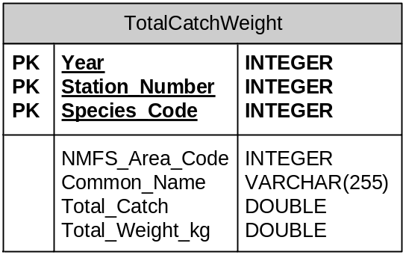
In general, the script does the following:
- The script first sums both the catch and length frequencies (the count of lengths taken) by Station, Stratum, and Species, so that weights calculated from the length data can be scaled up to actual catch (fewer fish are lengthed than are caught). The script also splits catch recorded using the group code for Shortraker and Rougheye (SRRE - 30051) based on the length data. After extrapolating lengths by strata, it then sums these for each station across strata.
- For all species that are lengthed, and for which growth factors are known, it calculates an estimate of weight based on lengths, scaled to total catch reported.
- For species that are not lengthed it sums the total catch of each species and multiplies it by a single average weight for the species derived from fishery observer data from 1990-2010 from longline vessels only.
Average weights and growth factors are stored by species in the Specie_Catch_Codes table.
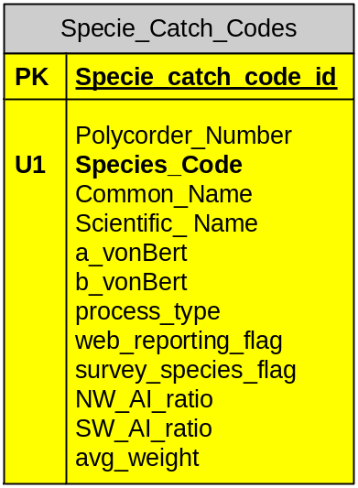

Logic Flow
The following diagram illustrates the logic flow of calculations performed by the ACL script and chapters following describe the calculations performed:
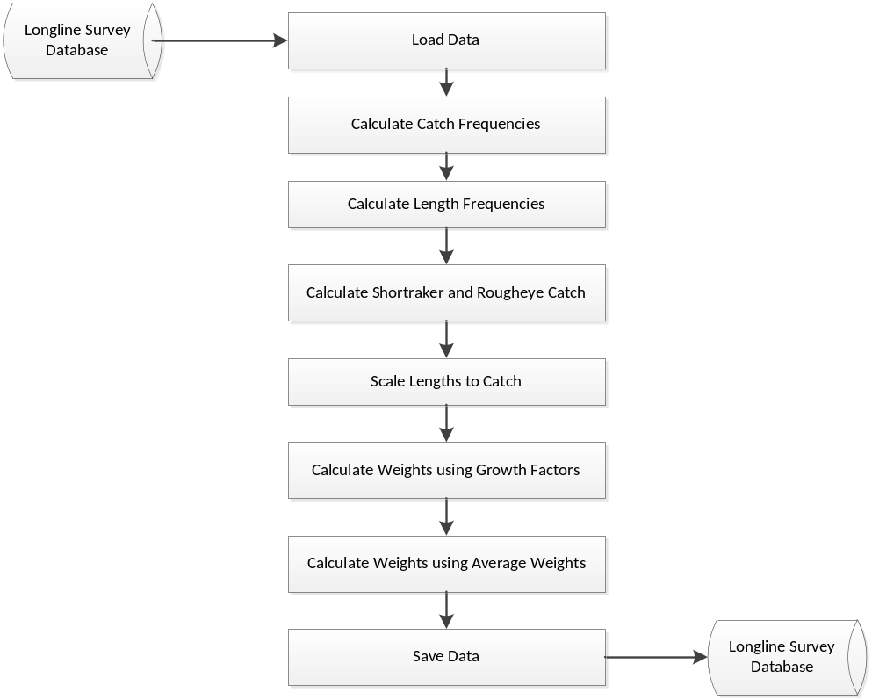

Load Data
The ACL script loads data from the Longline database using an ODBC data source from the following views and tables:
- Catches_View
- Lengths_View
- Specie_Catch_Codes
It loads all raw catch and length data for a given year.

Calculate Catch Frequencies
Catch frequencies, the number of fish caught, are summed by Station, Stratum, and Species.

Calculate Length Frequencies
Length frequencies, the number of lengths taken, are summed by Station, Stratum, and Species.

Calculate Shortraker and Rougheye Catch
Because it is difficult to distinguish between Shortraker and Rougheye rockfish at the time catch amounts are captured at sea, catch of Shortraker and Rougheye (SRRE) is combined in the database (Catch_View) under a single species code (30051).
Species are identified to Shortraker or Rougheye during the lengthing process and length frequencies are calculated and summed for each individual species code (Shortraker - 30576 and Rougheye - 30050).
An estimate of the total catch of the individual species is then calculated by determining a rate for each species by Station, Stratum, and Species:
SR rate = sum(SR lengths) / (sum(SR lengths) + sum(RE lengths))
RE rate = sum(RE lengths) / (sum(SR lengths) + sum(RE lengths))
These rates are then applied to the sum of catch of the group code (SRRE – 30051) by Station, Stratum, and Species:
Shortraker catch = sum(SRRE catch) * SR rate
Rougheye catch = sum(SRRE catch) * RE rate
Then the catch totals for SRRE are replaced by the calculated catch totals for each of the individual species (SR and RE).

Scale Lengths to Catch
Not all fish caught are necessarily lengthed, depending on the protocol for the species and sometimes on adverse conditions during the survey. Therefore, the total length frequencies, count of fish lengthed, will generally be less than or equal to the total catch of the same species at each station and stratum. Length frequencies must be scaled so that the sum of the lengths equals the sum of the catch. Then total weight of the catch can be calculated from the lengths by stratum, station, and species. So, after calculating the total catch and length frequencies, the length frequencies of the raw length data are scaled up to the total catch:
inflated_length_freq = length_freq * (catch_freq/length_freq)
Note that in rare instances, due to data capture errors, catch frequencies will be smaller than length frequencies for a station and stratum resulting in a smaller ‘inflated’ length frequency. In even rarer instances, there are lengths recorded and NO catch recorded for a given station, stratum and species. In this case, the length data is excluded from the calculations.

Calculate Lengths using Growth Factors
For species that are lengthed, for each length value recorded, a unit weight is calculated as:
unit_weight = (a_vonbert * length ^{b_vonbert}),
where unit_weight = a fish weight.
Then the raw length data is summarized by Station and Species (across all strata) and total weight is calculated as:
total_weight = sum(inflated_length_freq * unit_weight),
where inflated_length_freq = number of lengths taken at for each station, strata, species inflated to catch (see preceding section); unit weight = specimen weight; total_weight = total weight for each station, strata, and species.

Calculate Lengths using Average Weights
All catch records for species for which total weights were successfully calculated above, are removed so that total weights for species without growth factors can then be calculated.
For each of these remaining species, a generic average weight value (Specie_Catch_Codes.avg_weight) is used to calculate the total weight.
The remaining catch data is then summarized by Station and Species and total weight is calculated as:
total_weight = sum(catch) * avg_weight

Save Data
The calculated weights are then saved back to the TotalCatchWeight table in the database. The script pre-emptively pre-deletes any rows for the given year that may already exist in the table from previous executions.

AKFIN Extract
More detailed survey data is published to the scientific community and other interested parties through AKFIN which uses Oracle Answers to provide business intelligence features for searching and summarizing the data online. Each time major changes to the survey data are made (typically once a year after completing the survey data import process) a new survey data extract is prepared and shipped (emailed) to AKFIN to import into its data warehouse.
The AKFIN Extract process is executed using BCP. A command file (bcpExport.cmd) is run to extract the contents of the following tables and views to .csv files:
- Catch_Summary_View_AKFIN (view)
- Depth_Summary_View_AKFIN (view)
- Specie_Catch_Codes_AKFIN (view)
- Haul_View_AKFIN (view)
- Length_Summary_View_AKFIN (view)
- AreaStratumRPN_AKFIN (view)
- AreaStratumRPN_depred_AKFIN (view)
- Age_View_AKFIN (changed 2012) (view)
- Area_View_AKFIN (this is the old, it is not needed now that we have Stations_view_AKFIN)
- Depth_Stratum (Table)
- LengthRPN_byArea_3to7_AKFIN (view)
- LengthRPN_byArea_3to7_depred_AKFIN (view)
- LengthRPN_byArea_AllStrata_AKFIN (view)
- LengthRPN_byArea_AllStrata_depred_AKFIN (view)
- Stations_view_AKFIN (view)
- AreaRPN_3to7_AKFIN (view)
- AreaRPN_3to7_depred_AKFIN (view)
- AreaRPN_AllStrata_AKFIN (view)
- CouncilSablefishArea_AllStrata (table)
- CouncilSablefishArea_3to7_depred (table)
- FMP_AllStrata (table)
- FMP_Subarea_AllStrata (table)
- FMP_Subarea_3to7_depred (table)
- AK_wide_3to7_depred (table)
Catch_with_nulls is recreated by AKFIN in their database.
The AKFIN Extract process is run by executing the bcpExport.cmd file . The command file and all dependent files and scripts are located at:
\\nmfs.local\akc-abl\MESA\Longline survey\AKFINExtractBCP.
Current version is bcbexport.cmd (9/16/16)
The command file will take a while to run and will create output .csv files in the same folder. When the process completes, zip up the .csv files in the folder and send them to AKFIN using their ftp site. As it is running files will have _nh (no header). They are overwritten when finished and nh will be gone.
You can also run from a command window to see error messages if not working.
I:
cd “longline survey\R\Calcrpw”
bcpExport.cmd


226 Seward St.
Suite 210
Juneau, AK 99801
Phone: (907) 586-6167
Fax: (907) 586-2996

